Team CODECoNQUERORS
Team Leader Name :- Himesh Ganorkar
Problem Statement :- Lack of Access to Quality Education in Underserved Communities

Brief Solution :-
Addressing the lack of access to quality education in underserved communities requires a multifaceted approach. Firstly, increased funding must be directed towards these areas to improve infrastructure, provide up-to-date resources, and attract qualified teachers. Secondly, implementing community-based educational programs that tailor curricula to local needs and cultural contexts can enhance engagement and relevance. Thirdly, leveraging technology to bridge the digital divide through accessible online learning platforms and digital literacy initiatives is crucial. Fourthly, providing comprehensive support services, including mentorship, counseling, and nutritional programs, can address the non-academic barriers that hinder student success. Finally, fostering strong partnerships between schools, families, and community organizations can create a supportive ecosystem that prioritizes education and empowers students to thrive.
Opportunities :-
- How different is it from any of the other existing ideas ?
Ans :- Many existing educational initiatives focus on isolated aspects, like technology access or teacher training. However, the proposed approach distinguishes itself by emphasizing a holistic, community-centered strategy. It prioritizes the interconnectedness of funding, culturally relevant curriculum, accessible technology, comprehensive support services, and strong community partnerships. Instead of viewing these as separate interventions, it advocates for a synergistic approach, recognizing that addressing the complex challenges in underserved communities requires a coordinated and multi-pronged effort. Crucially, the focus on tailoring education to the specific needs and cultural contexts of each community, rather than a one-size-fits-all model, sets it apart from many broader, less localized programs. It's about building a robust ecosystem, not just patching holes.
- How will it be able to solve the problem?
Ans :- This holistic approach aims to solve the problem by tackling the root causes of educational inequity. Increased funding and resource allocation directly address the material deficits that hinder learning. Culturally relevant curricula and community-based programs foster engagement and a sense of belonging, making education more meaningful for students. Bridging the digital divide with accessible technology and digital literacy initiatives ensures equitable access to modern learning tools. Comprehensive support services, like mentorship and counseling, address the socio-emotional barriers that often impede academic success. By fostering strong partnerships between schools, families, and community organizations, a supportive network is created, reinforcing the importance of education and providing students with the necessary resources and encouragement to thrive. In essence, it aims to create a self-sustaining educational ecosystem that empowers students, addresses their diverse needs, and ultimately breaks the cycle of educational disadvantage.
- USP of the proposed solution
Ans :- The unique selling proposition (USP) of this proposed solution lies in its deeply integrated, community-centric design. It moves beyond isolated interventions by creating a synergistic educational ecosystem. Unlike programs that focus solely on technology or funding, this approach prioritizes the interwoven nature of those elements with cultural relevance, comprehensive support, and strong community partnerships. The key differentiator is the emphasis on hyper-localization, tailoring educational strategies to the specific needs and cultural contexts of each underserved community. This ensures that interventions are not only effective but also deeply resonant with the students they serve. By building a sustainable support network, it empowers communities to take ownership of their educational outcomes, fostering long-term, systemic change rather than temporary fixes.
Program Diagram
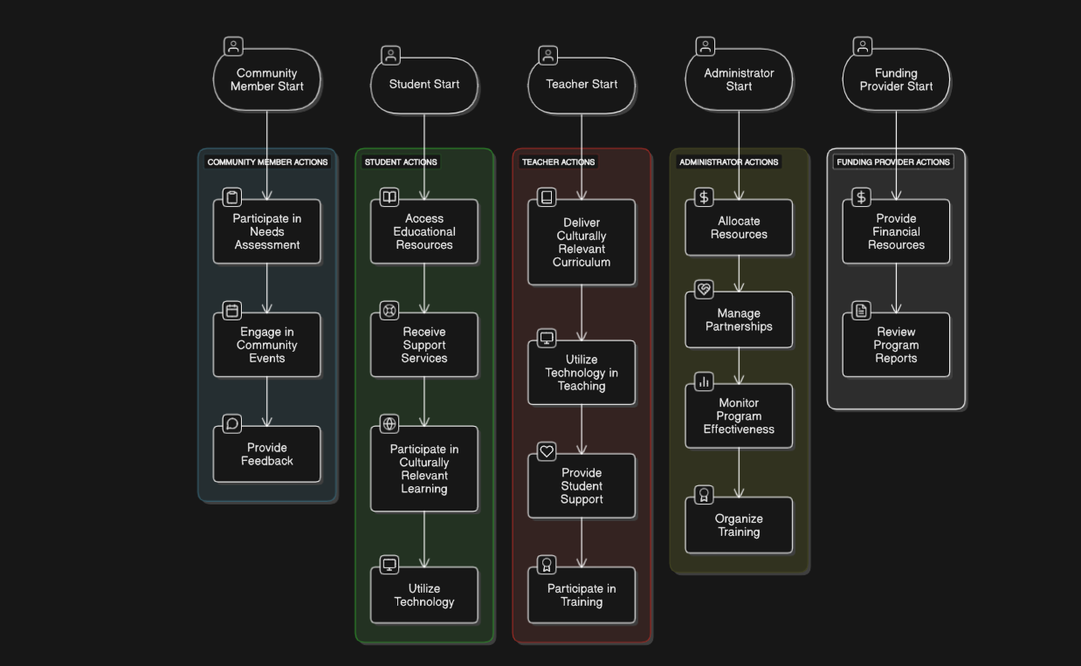

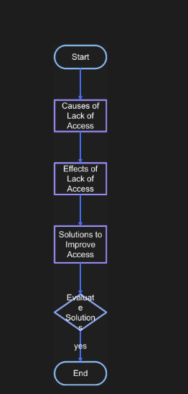
Architecture diagram
Technologies to be used in the solution
(Additional points for those who are:
To effectively address the lack of access to quality education in underserved communities, a strategic blend of technologies is crucial. Firstly, cloud-based learning management systems (LMS) can deliver educational content remotely, overcoming geographical barriers. These platforms can host interactive lessons, assignments, and assessments, ensuring consistent access to learning materials. Secondly, mobile learning (m-learning) solutions, utilizing smartphones and tablets, can reach students in areas with limited internet connectivity. Offline content delivery and SMS-based communication can provide essential educational resources. Thirdly, AI-powered adaptive learning platforms can personalize educational content based on individual student needs, optimizing learning outcomes. These platforms can track progress, identify knowledge gaps, and provide targeted feedback. Fourthly, virtual and augmented reality (VR/AR) technologies can create immersive learning experiences, enhancing engagement and comprehension, particularly in subjects like science and history.
For projects built on IDX, leveraging its cloud-based development environment can streamline the creation and deployment of these educational solutions. IDX's ability to facilitate remote collaboration and provide access to powerful development tools can accelerate the development process. Integrating Gemini APIs can further enhance the solution by enabling AI-powered features such as personalized learning recommendations, automated content generation, and intelligent tutoring systems. Gemini's natural language processing capabilities can also facilitate seamless communication between students, teachers, and community members, fostering a supportive learning environment. Finally, using technologies that allow for data analytics will be critical to track student progress, and to provide feedback to stakeholders.
Snapshots of the MVP :-
For an MVP addressing the lack of access to quality education in underserved communities, snapshots would showcase key functionalities. Imagine these scenes: a student in a remote area accessing an offline lesson on a tablet, demonstrating the mobile learning component. Another snapshot would display a teacher using an AI-powered adaptive learning platform, showing personalized feedback being delivered to a student based on their progress. A third would capture a community workshop, highlighting the use of a cloud-based LMS for collaborative learning and resource sharing. A fourth snapshot would show students using VR headsets to explore a historical site, illustrating the immersive learning aspect. Finally, a dashboard snapshot would display data analytics, visualizing student progress and engagement metrics for educators and stakeholders, showcasing the MVP's data-driven approach to improvement. These snapshots collectively would demonstrate the MVP's ability to deliver accessible, personalized, and engaging educational experiences, tailored to the unique challenges of underserved communities.
Additional Details :-
Future development for this educational solution would focus on expanding its reach and deepening its impact. One key area is the integration of more sophisticated AI capabilities, such as automated content generation tailored to specific regional dialects and cultural nuances, ensuring greater relevance and engagement. Expanding the VR/AR component to include immersive vocational training modules would provide students with practical skills for local job markets. Further development would also involve creating robust community feedback loops, enabling ongoing refinement of the platform based on user input and evolving needs. Integrating blockchain technology could secure student records and credentials, fostering greater transparency and trust. Long-term sustainability would be addressed through developing local teacher training programs, empowering communities to maintain and expand the educational platform independently. Finally, exploring partnerships with local businesses and organizations to provide internships and apprenticeships would create a direct pathway from education to employment, breaking the cycle of disadvantage.
Provide links to your:
Github Link :- https://github.com/Ganorkarhimesh/Hackathons
Video Link :- https://youtu.be/Un5msddQl6U
MVP Link :- https://www.intellecap.com/bringing-quality-education-to-the-most-underserved-sections/

THANK YOU

